3GPP TSG RAN WG1 Meeting #125 R1-2604573
Dalian, China, May 18-22, 2026

Agenda Item: 10.8.3
Source: PHY Wireless
Title: On Reference Signal Design for 6G Integrated Sensing and Communication
Document for: Discussion, Decision

Introduction
Integrated sensing and communication (ISAC) is anticipated to be a key feature in 6G [1, 2] with a wide variety of use cases [3]. Its design is being actively studied in 3GPP.
An overarching ethos of the 6G standardization process is to keep it simple [4]:
3GPP to create lean and streamlined standards for 6G, e.g., by dimensioning an appropriate set of functionalities, minimizing the adoption of multiple options for the same functionality, avoiding excessive configurations, etc. Any exception to the above shall be well justified.
3GPP to create lean and streamlined standards for 6G, e.g., by dimensioning an appropriate set of functionalities, minimizing the adoption of multiple options for the same functionality, avoiding excessive configurations, etc. Any exception to the above shall be well justified.
This contribution considers waveform design and frame structure for ISAC, with attention to sensing reference signals (RS) and integration with communication. It straddles Agenda Items 10.8.2 and 10.8.3 of the Study Item. The contribution puts the streamlined ethos [4] front and center, with a special focus on practical, deployable solutions aligned with operator needs. The solutions offer deployment flexibility and care for the sensitivities of power-constrained IoT devices.

Sensing configurations
Before diving into the reference signal design, various sensing configurations are reviewed. Sensing can be viewed generally as N transmitting nodes with M receiving nodes. In monostatic sensing, a single node acts as both the transmitter and receiver. Bistatic sensing has transmit and receive nodes on different nodes, and multistatic sensing generalizes to N > 1 or M > 1.
In the 6G cellular context, base stations (TRPs, aNBs, etc.) and mobile devices (UEs) can act as either transmitters or receivers. Downlink sensing can be viewed as TRP-to-UE, and uplink sensing as UE-to-TRP. UE-to-UE and TRP-to-TRP might be considered sidelink.
Some sensing use cases require knowledge of the node locations, while others do not, as summarized in Table 1.
Sensing can be viewed as two parts: 1) measurements (channel impulse response (CIR) estimation, Doppler (mobility) estimation) and 2) calculation (fusing together the measurements and possibly the node location to sense the RF environment).
These two parts can be done in a distributed manner. For example, in downlink sensing, the measurements are performed at the UEs. Those measurements can be transmitted to a server (a sensing function (SF)), where the calculation is performed. This is like UE-assisted OTDOA in 4G and 5G, where a location server performs the position calculation. UE-based sensing is when the UE performs the calculation. To do so, it may need location information of the TRPs. For uplink sensing, the measurements are performed at the TRPs and are fed to the SF for calculation.
Table 1: When node locations are required in ISAC use cases.
Category | Node locations needed | Example use cases
Geometry-based sensing (position, velocity, mapping) | Yes | Passive object localization, multistatic tracking, drone detection, radar imaging, environmental mapping
Relative / feature-based sensing | No | Presence detection, motion detection, gesture recognition, breathing monitoring, blockage detection
Assisted communication (ISAC for comms optimization) | No | Beam selection, beam tracking, link adaptation, handover optimization, blockage prediction

- 6G ISAC may support multiple sensing configurations, including monostatic, bistatic, and multistatic sensing; uplink, downlink, and sidelink sensing; and sensing with or without node location information. Measurement extraction and sensing calculation may also be performed at different network entities.

Given the many possibilities for 6G ISAC configurations, 3GPP should downselect for a streamlined standard [4]. It is recommended that downlink TRP-UE sensing is prioritized. This configuration places less burden on UEs, as sensing RS transmission is handled by the TRPs. The TRPs have more power, offering better, more reliable coverage. Their location is known, whereas UEs are inherently mobile and exhibit greater location uncertainty.
- 3GPP should prioritize downlink multistatic TRP-to-UE sensing as an initial 6G ISAC configuration.
Multi-TRP-UE sensing offers an additional benefit: enabling UE location estimation via OTDOA. In downlink OTDOA, the UE makes time-of-arrival estimates (TOAs) of surrounding base stations. Then, using the locations of the base station transmissions, the UE’s location can be estimated using hyperbolic location calculation. Downlink OTDOA is just a special case of downlink sensing, in which the TOA is one part of the CIR.
- Downlink OTDOA can be viewed as a special case of downlink sensing, where TOA estimation is derived from the CIR.

Waveforms
Waveform selection remains an active area of research in 6G. For sensing, frequency-modulated continuous wave (FMCW) and orthogonal time-frequency space (OTFS) are competing with traditional 4G/5G cyclic prefix orthogonal frequency-division multiplexing (CP-OFDM). Table 2 summarizes the strengths and weaknesses of the various waveforms.

This contribution recommends prioritizing CP-OFDM for 6G downlink ISAC sensing. CP-OFDM has a long history in 3GPP, with success in the marketplace and robust vendor implementations. With careful RS design, CP-OFDM can work well for sensing, as the remainder of this Tdoc explores.

Table 2: Comparison of candidate waveforms for 6G ISAC sensing.
Waveform | Strengths for sensing | Challenges in 6G cellular | Comments
CP-OFDM | Native time-frequency grid, flexible resource allocation, supports multi-TRP coordination, compatible with RS-based sensing | Not radar-optimized; requires careful RS design for sensing performance | Benefits from mature implementation (FFT/IFFT-based receivers) and reuse of established cellular design principles
FMCW | Excellent range resolution, simple processing, mature radar performance | Poor alignment with cellular frame structure, limited multi-node coordination, not designed for joint comm/sensing | Well suited for standalone radar, less suitable for networked 6G ISAC
OTFS | Native delay-Doppler representation, robust to high mobility, unified comm and sensing framework | Requires new receiver processing, limited industry maturity, integration complexity with existing systems | Promising for ISAC, but introduces significant changes relative to established OFDM-based implementations

- 3GPP should prioritize CP-OFDM for downlink ISAC sensing, with careful attention to the sensing reference signal time-frequency design.

Ambiguity function

In designing the 6G ISAC reference signals, it is useful to start from first principles.

The ambiguity function provides a joint characterization of delay and Doppler observability for a transmitted signal $s\left(t\right)$:

$$A\left(τ,ν\right)=\int_{-∞}^{∞}{s\left(t\right)} s^{*}\left(t-τ\right) e^{-j2πνt}dt$$

For OFDM, the ambiguity function is simplified to

$$A_{RS}\left(τ,ν\right)=\sum_{\left(k,n\right)∈S}{e^{-j2πkF_{sub}τ}e^{j2πνnT_{sym}}}$$

where $F_{\text{sub}}$ is the subcarrier spacing and $T_{\text{sym}}$ is the OFDM symbol time. The set $S$ defines the time-frequency lattice of the reference signals.

Along the frequency axis, comb-$N_{f}$ designs transmit known pilots every $N_{f}$ subcarriers. Along the time axis, comb-$N_{t}$ designs have known pilots every $N_{t}$ OFDM symbols. If the universe were to consist of a single base station transmitting sensing RS, every resource element would contain known pilots, resulting in comb-1 in both dimensions. For several base stations to coexist without time-frequency interference, $N_{f}>1$ is useful. By frequency shifting the RS by one subcarrier across $N_{f}$ symbols, the effective comb pattern is comb-1 when applying coherent combining across the $N_{f}$-symbol sensing occasion. The effective comb-1 is designed into 5G NR positioning reference signals (PRS). There, different $N_{f}$ are supported (2, 4, 6, 12) [5]. This is generally a good idea and provides a starting point for 6G ISAC RS design.

Another good idea is muting. Again borrowing from 4G and 5G PRS, muting bits are applied to the base station PRS occasion transmission. If the muting bit is 1, the station transmits; otherwise, it does not. This method improves the hearability of many base stations, a critically important metric for downlink OTDOA. The improved spatial diversity also benefits 6G ISAC sensing.

The previous generation PRS is only concerned with TOA estimation. But for 6G ISAC sensing, the CIR contains the information of the RF environment. For passive object tracking, multiple CIR snapshots are needed to see the object’s mobility. This is analogous to a picture being a single CIR snapshot, and a movie being a time evolution of many pictures. So, this 6G ISAC reference signal design needs to allow for measurement of these CIR snapshots.

- 4G and 5G positioning reference signals provide a useful starting point for 6G ISAC sensing reference signal design, but they are not sufficient to guarantee per-path Doppler estimation.

Limitations of NR communication reference signals for sensing
A hot topic in the 6G ISAC study is, “Can existing communication reference signals also be used for sensing?” Since 6G communication RS are currently under study and development, it is useful to address the reusability question for 5G communication RS. This contribution concludes that the answer to reuse is “no” if the 6G communication RSs are like those of 5G.
Figure 1 shows an example PDSCH for a UE spanning four resource blocks. DM-RS are used to measure the channel’s frequency selectivity, and PT-RS are used to measure the channel's time selectivity. They serve their purpose well for communication, but not for sensing. First, they are UE-specific, so UE A cannot measure the RS scheduled for UE B. Second, their bandwidth is not guaranteed, which impacts delay resolution. Third, the PT-RS provides good time-sampling for bulk Doppler but not per-path Doppler. As discussed later, the RS’s delay support depends on the subcarrier spacing and the frequency-domain comb pattern. For 30 kHz subcarrier spacing with comb-24, the delay support is just 208 meters.
Other downlink reference signals in 5G NR include the synchronization signals (SSBs) and PRS. SSBs are narrowband, so not great for high-resolution sensing. They are good for what they do: cell discovery, but not for general-purpose sensing. As already observed, 5G PRS are a good starting point for 6G ISAC reference signals, but need some work. Besides not guaranteeing per-path Doppler estimation, they are optional in 5G, creating deployment risks. 6G ISAC is not considered an optional feature, so the reference signal design for 6G sensing must be integral—integrated—into the mandatory design.
- If 6G communication reference signals follow a similar structure to 5G communication reference signals, they are unlikely to be sufficient for general-purpose sensing.

Proposed 6G pulsed-radar ISAC (PR-ISAC) framework
A sensing occasion is defined as a contiguous set of OFDM symbols used to form one or more CIR observations, and a communication occasion is a contiguous set of OFDM symbols used for regular communications. The two are orthogonal. The sensing occasions are short relative to the communication occasions, forming pulses. The system is therefore a pulse-radar ISAC (PR-ISAC) system.
The sensing occasions may or may not span the full system bandwidth. Partial-band PR-ISAC provides more communication resources, but it introduces standards and deployment complexity. In the spirit of streamlined 6G standards [4], it is recommended to prioritize full-band PR-ISAC.
- 6G ISAC should prioritize a pulsed-radar ISAC framework in which full-band sensing occasions are time-multiplexed with longer communication occasions.

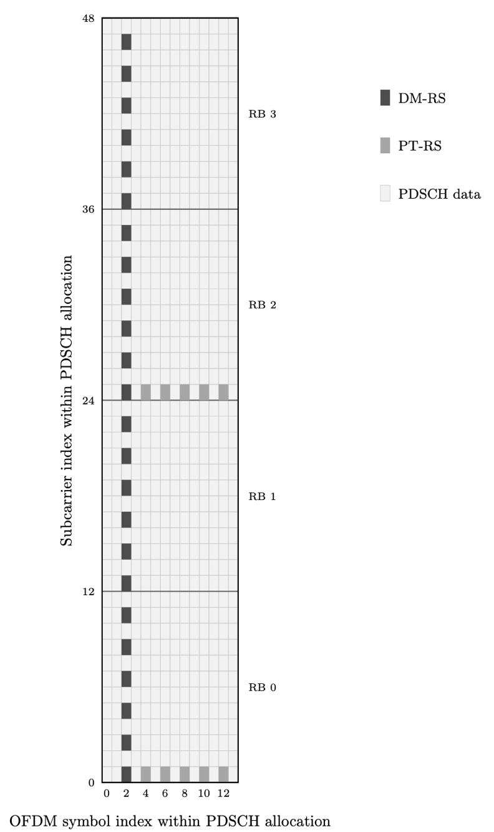
Figure 1: Example PDSCH allocation with DM-RS and PT-RS. The example uses PDSCH DM-RS configuration type 1 with a single DM-RS symbol at $l=2$ and PT-RS with $L_{\text{PT-RS}}=2$ and $K_{\text{PT-RS}}=2$. The PT-RS is sparse in frequency across resource blocks and is present only within the scheduled PDSCH allocation.

The sensing occasion is constructed of
$$N_{\text{sense}}=N_{f}×N_{\text{CIR}}$$
OFDM symbols. A single OFDM symbol is comb-$N_{f}$, and contiguous sets of $N_{f}$ OFDM symbols are effectively comb-1. This is achieved by cycling through all $N_{f}$ subcarrier frequency shifts. A CIR estimate may be performed with each of the $N_{\text{CIR}}$ sets to enable Doppler estimation. Since the sensing occasion spans the full system bandwidth, and each CIR is comb-1, the individual paths can be monitored for per-path Doppler estimation. This feature is required for passive object tracking, for example.
The sensing occasion duration is
$$T_{\text{sense}}=N_{\text{sense}}T_{\text{sym}}= \frac{N_{f}N_{\text{CIR}}}{F_{\text{sub}}}$$
(For a simpler discussion here, the OFDM symbol time is assumed to be the inverse of the subcarrier spacing $T_{\text{sym}}= F_{\text{sub}}^{-1}$. This, of course, ignores the effect of the cyclic prefix; accounting for the CP is a trivial extension to this analysis.). For example, with 30 kHz subcarrier spacing, comb-6, and four CIR estimates per occasion, the duration is $T_{\text{sense}} = 6 × 4 / 30 = 0.8$ ms.
Figure 2 draws a sensing occasion for $N_{f}= 6$, $N_{CIR}= 3$ for a single twelve-subcarrier resource block. The pattern obviously extends in frequency up to the system bandwidth (i.e., 20 or 40 MHz, etc.).
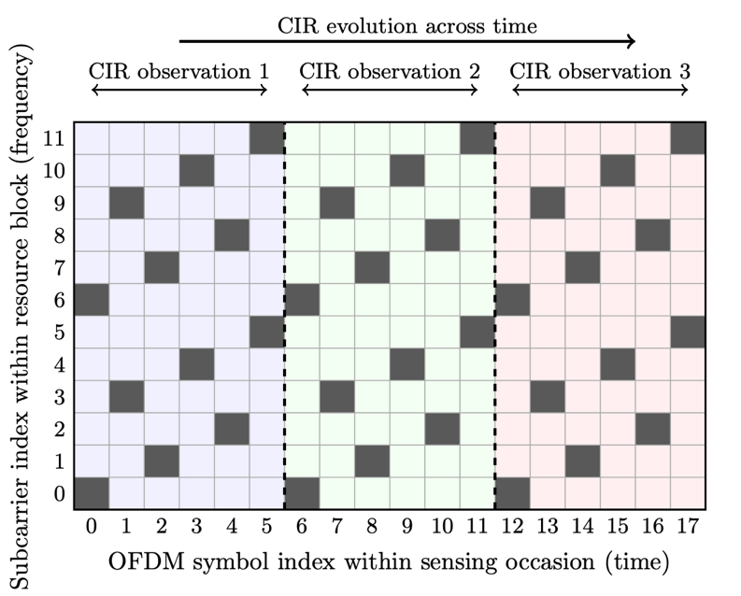
Figure 2: Example sensing occasion with comb-6 sampling and $N_{CIR}= 3$ repeated CIR observations. Each 6-symbol group provides one effective comb-1 CIR observation; repeated groups support per-path Doppler estimation.
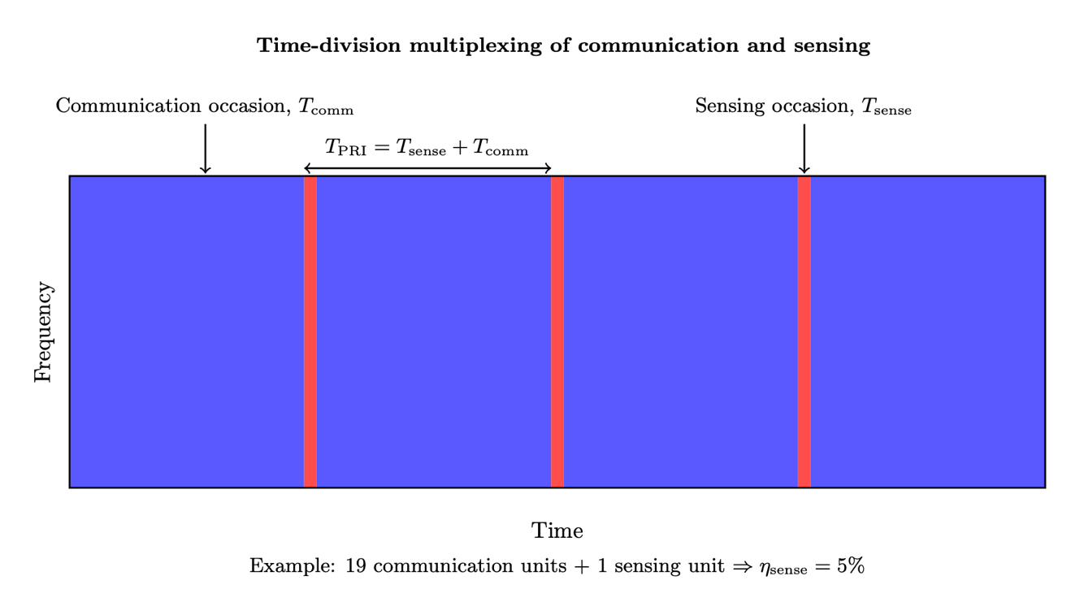
Figure 3: Pulsed radar ISAC: sensing occasions time-multiplexed between communication occasions. The pulse repetition interval is labeled as $T_{PRI}$.

Figure 3 illustrates the frame structure of PR-ISAC. The pulse repetition interval is
$$T_{PRI}= T_{sense}+ T_{comm},$$
where $T_{comm}$ is the communication occasion period. The sensing overhead is
$$η_{sense}= \frac{T_{sense}}{T_{PRI}}.$$
The figure shows an overhead of 5%. Continuing with the $N_{f}= 6$, $N_{CIR}= 4$, $F_{sub}= 30$ kHz example, $T_{sense}= 0.8$ ms, $T_{comm}= 15.2$ ms, and $T_{PRI}= 16$ ms. The scene update rate is
$$F_{scene}= \frac{1}{T_{PRI}},$$
or 62.5 Hz in the example set of parameters.

Sensing occasion muting
Sensing occasion muting increases the number of TRPs detectable at the UE. Improved spatial diversity enhances both sensing and positioning performance. It is used in 4G and 5G PRS and should be applied in 6G to improve RF environmental sensing and UE positioning.
Consider the case of $N_{f}= 6$. For any given sensing occasion, up to six cells can be measured interference-free. Now, suppose 4-bit muting is applied, with one-1 and three-0s. The interference-free TRP detection rate increases from 4 to 24. Figures 4 and 5 illustrate the idea.
In 4G and 5G, the muting bits are communicated through the LPP [6]. For a streamlined 6G specification [4], the LPP can be avoided by mapping the muting information into the physical cell index (PCI) or a sensing index. For example, the frequency shift can be
$$v_{shift}= mod\left(PCI, N_{f}\right)$$
while the muting phase can be
$$p_{muting}= \left\lfloor \frac{PCI}{N_{f}}\right\rfloor mod N_{phase}.$$
This creates a two-level structure: transmitters are separated first in frequency by comb shift and then in time by muting phase. The exact identity and mapping rule can be further studied. The key principle is that the receiver can infer the sensing transmission pattern with little or no explicit bitmap signaling.
- 6G ISAC should support deterministic multi-TRP sensing occasion muting, preferably with little or no explicit bitmap signaling.

This does not preclude offering some assistance to the UEs to aid in detecting cells farther away, where the PCI is difficult to infer. Additional assistance to the UE for the TRP locations may be provided to enable UE-based OTDOA in 6G. UE-based OTDOA is an attractive feature for both 4G and 5G, particularly for low-cost IoT UEs and applications that cannot afford dedicated GNSS, either from a BOM or power perspective (asset trackers, pet trackers, etc.). Low-cost UE positioning remains an important feature in 6G for these same applications. Its use will find new applications in sensing, as many scenarios require information about the UE's location.
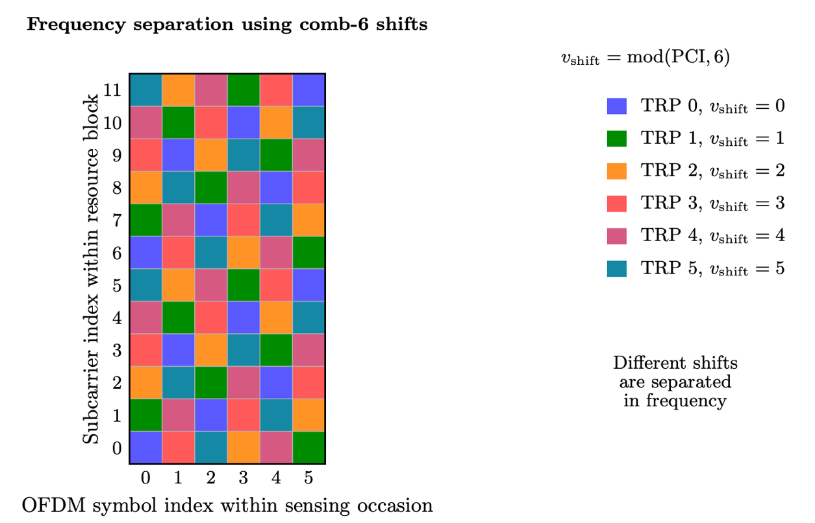
Figure 4: Frequency-domain separation of up to six transmitters within a single sensing occasion using the comb-6 shift $v_{shift}=mod\left(PCI, 6\right)$. In this example, TRP 0 through TRP 5 occupy different comb offsets and can be observed without frequency-domain collision.

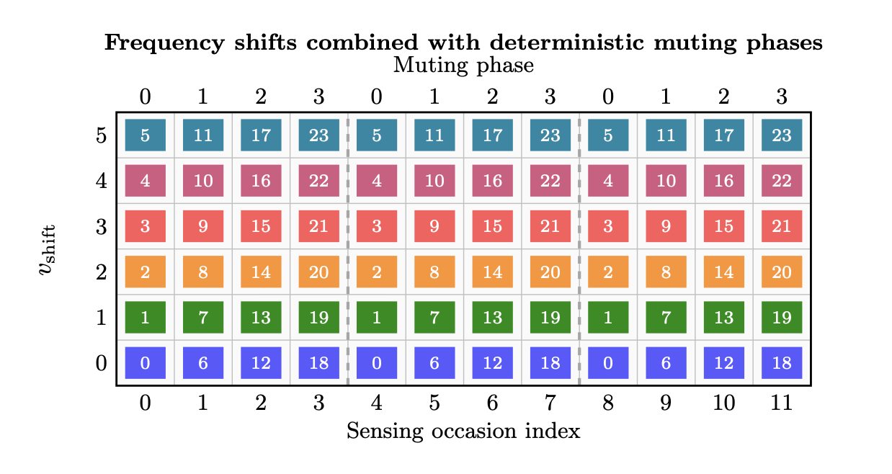
Figure 5: Example deterministic multi-TRP structure using six frequency shifts and four muting phases. Transmitters with the same frequency shift are separated across sensing occasions.

Range-Velocity support and resolution
With the 6G PR-ISAC framework outlined in the previous section, attention now turns to its underlying sensing capabilities, including range (delay) and velocity (Doppler) estimation, support, and resolution.

Support
The range support is just a function of the subcarrier spacing:
$$R_{support}= ±\frac{c}{{2F}_{sub}}$$
where $c$ is the speed of light. For a 30 kHz subcarrier spacing, this comes out to $±5$ km. The effective comb-1 pattern allows full delay support for a given subcarrier spacing.
The radial velocity support depends on how frequently CIR snapshots are observed and on the carrier wavelength $λ$:
$$v_{support}= ±\frac{λ}{{2T}_{CIR}}= ±\frac{c}{2f_{c}T_{CIR}}$$
For $F_{sub}= 30$ kHz, the resulting Doppler and velocity supports for $N_{f}= 6$ and 12 are summarized in Table 3.
Table 3: Velocity support for $F_{sub}=30$ kHz and two different center frequencies.
$$N_{f}$$ | Velocity support at 1 GHz | Velocity support at 10 GHz
6 | $±750$ m/s | $±75$ m/s
12 | $±375$ m/s | $±37.5$ m/s

These range and velocity support values are reasonable for many cellular sensing use cases. In terms of range, the UE is synchronized to the serving-cell sensing occasion. The CIR between the serving cell and the UE can span approximately 5 km, while neighboring-cell CIRs can be observed within the same $±5$ km observation window.
The velocity support is also sufficient for many practical scenarios. For example, with $N_{f}=12$, the velocity support is approximately $±375$ m/s at 1 GHz and $±37.5$ m/s at 10 GHz. Thus, the same CIR sampling interval provides very large velocity support at lower carrier frequencies, while at higher carrier frequencies the support becomes more relevant for fast-moving objects, vehicles, and other high-mobility scenarios. In general, smaller $N_{f}$ provides larger velocity support at the cost of more frequent CIR estimation.

Resolution
The range resolution is determined by the occupied bandwidth $B$, while the velocity resolution is determined by the coherent processing interval (CPI), denoted $T_{CPI}$. Specifically,
$$R_{res}≈\frac{c}{2B},$$
And
$$v_{res}≈\frac{c}{f_{c}T_{CPI}}.$$
Example delay resolutions are shown in Table 4.
Table 4: Range resolution versus occupied bandwidth.
Bandwidth, $B$ | Range resolution, $R_{res}$
20 MHz | 7.5 m
40 MHz | 3.8 m

For $K$ coherently processed sensing occasions, the CPI includes the sensing time from all $K$ occasions and the communication gaps between them. Since there are $K - 1$ communication gaps,
$$T_{CPI}=KT_{sense}+\left(K-1\right)T_{comm}=\left(K-1\right)T_{PRS}+T_{sense}.$$
Table 5 shows example velocity resolutions for different CPI durations at 10 GHz. Even with modest values of $K$, the proposed PR-ISAC framework provides sufficient resolution for many practical sensing scenarios, including vehicle tracking, pedestrian detection, drone sensing, and fine human-motion monitoring. These sensing capabilities align well with several 6G ISAC use cases identified in [3], including UAV supervision, environmental object reconstruction, and network-assisted autonomous driving.
Table 5: Velocity resolution versus CPI for $T_{sense}=0.8$ ms, $T_{PRI}=20$ ms, and $f_{c}=10$ GHz.
$$K$$ | $$T_{CPI}$$ | Velocity resolution at 10 GHz | Example sensing capability
1 | 0.8 ms | 37.50 m/s | Fast vehicles
2 | 20.8 ms | 1.44 m/s | Highway vehicles
5 | 80.8 ms | 0.37 m/s | Vehicles and pedestrians
20 | 380.8 ms | 0.08 m/s | Pedestrians and drones
100 | 1980.8 ms | 0.02 m/s | Breathing and subtle motion

The numerical examples in this section assume 30 kHz subcarrier spacing and a representative set of sensing parameters for illustration. However, the PR-ISAC framework is inherently parameterized and may be adapted to different deployment requirements through the selection of subcarrier spacing, occupied bandwidth, comb factor $N_{f}$, number of CIR observations $N_{CIR}$, sensing overhead $η_{sense}$, and coherent processing depth $K$. These parameters expose the primary sensing tradeoffs, including range support, velocity support, range resolution, velocity resolution, and scene refresh rate, while still enabling a streamlined 6G ISAC framework with relatively low configuration complexity.
- A small set of PR-ISAC parameters can expose the main sensing trade-offs: subcarrier spacing controls range support, sensing bandwidth controls range resolution, CIR sampling controls velocity support, PRI controls scene update rate, and CPI controls velocity resolution.

Summary
This contribution makes the following observations:
- Observation 1: 6G ISAC may support multiple sensing configurations, including monostatic, bistatic, and multistatic sensing; uplink, downlink, and sidelink sensing; and sensing with or without node location information. Measurement extraction and sensing calculation may also be performed at different network entities.
- Observation 2: Downlink OTDOA can be viewed as a special case of downlink sensing, where TOA estimation is derived from the CIR.
- Observation 3: 4G and 5G positioning reference signals provide a useful starting point for 6G ISAC sensing reference signal design, but they are not sufficient to guarantee per-path Doppler estimation.
- Observation 4: If 6G communication reference signals follow a similar structure to 5G communication reference signals, they are unlikely to be sufficient for general-purpose sensing.
- Observation 5: A small set of PR-ISAC parameters can expose the main sensing tradeoffs: subcarrier spacing controls range support, sensing bandwidth controls range resolution, CIR sampling controls velocity support, PRI controls scene update rate, and CPI controls velocity resolution.
This contribution makes the following proposals:
- Proposal 1: 3GPP should prioritize downlink multistatic TRP-to-UE sensing as an initial 6G ISAC configuration.
- Proposal 2: 3GPP should prioritize CP-OFDM for downlink ISAC sensing, with dedicated attention to the sensing reference signal time-frequency design.
- Proposal 3: 6G ISAC should prioritize a pulsed-radar ISAC framework in which full-band sensing occasions are time-multiplexed with longer communication occasions.
- Proposal 4: 6G ISAC should support deterministic multi-TRP sensing occasion muting, preferably with little or no explicit bitmap signaling.

References
- 3GPP TSG RAN, “RP-253876: Revised SID: Study on 6G Radio.” 3GPP TSG RAN Meeting #110, Baltimore, US, Dec. 2025. Rel-20 Study Item, FS.6G-Radio.
- ITU-R, “Framework and overall objectives of the future development of IMT for 2030 and beyond.” Recommendation ITU-R M.2160, 2023.
- “3GPP TR 22.870: Study on 6G Use Cases and Service Requirements.”
- 3GPP TSG RAN, “RP-250766: Lean and Streamlined 6G Standards.” 3GPP TSG RAN Meeting #107, Incheon, Korea, Mar. 2025. Agenda Item 16, Document for endorsement (Rel-20 6G workshop).
- “3GPP TS 38.211: NR; Physical channels and modulation.”
- “3GPP TS 37.355: LTE Positioning Protocol (LPP).”

